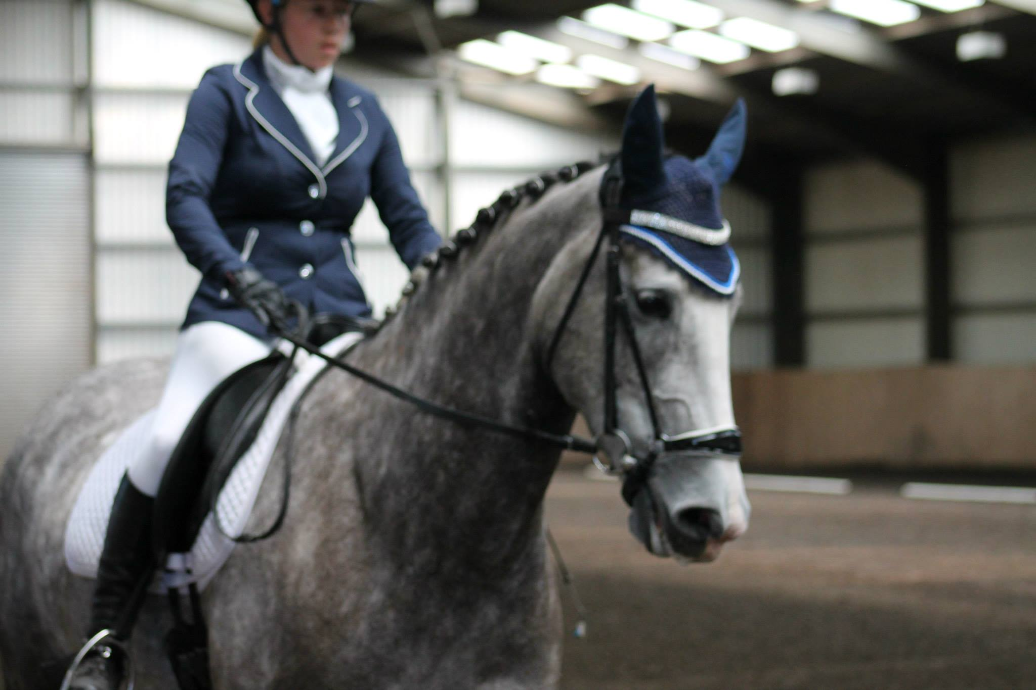
Virtual Charity Dressage Competition
In aid of Aware NI
Laurel View Equestrian Centre

Contents
Schedule 3
Prices 3
Key dates 3
Where to find tests? 4
Entering and Payment 4
How to record tests? 5
What to wear? 5
Summary of Aware NI 6

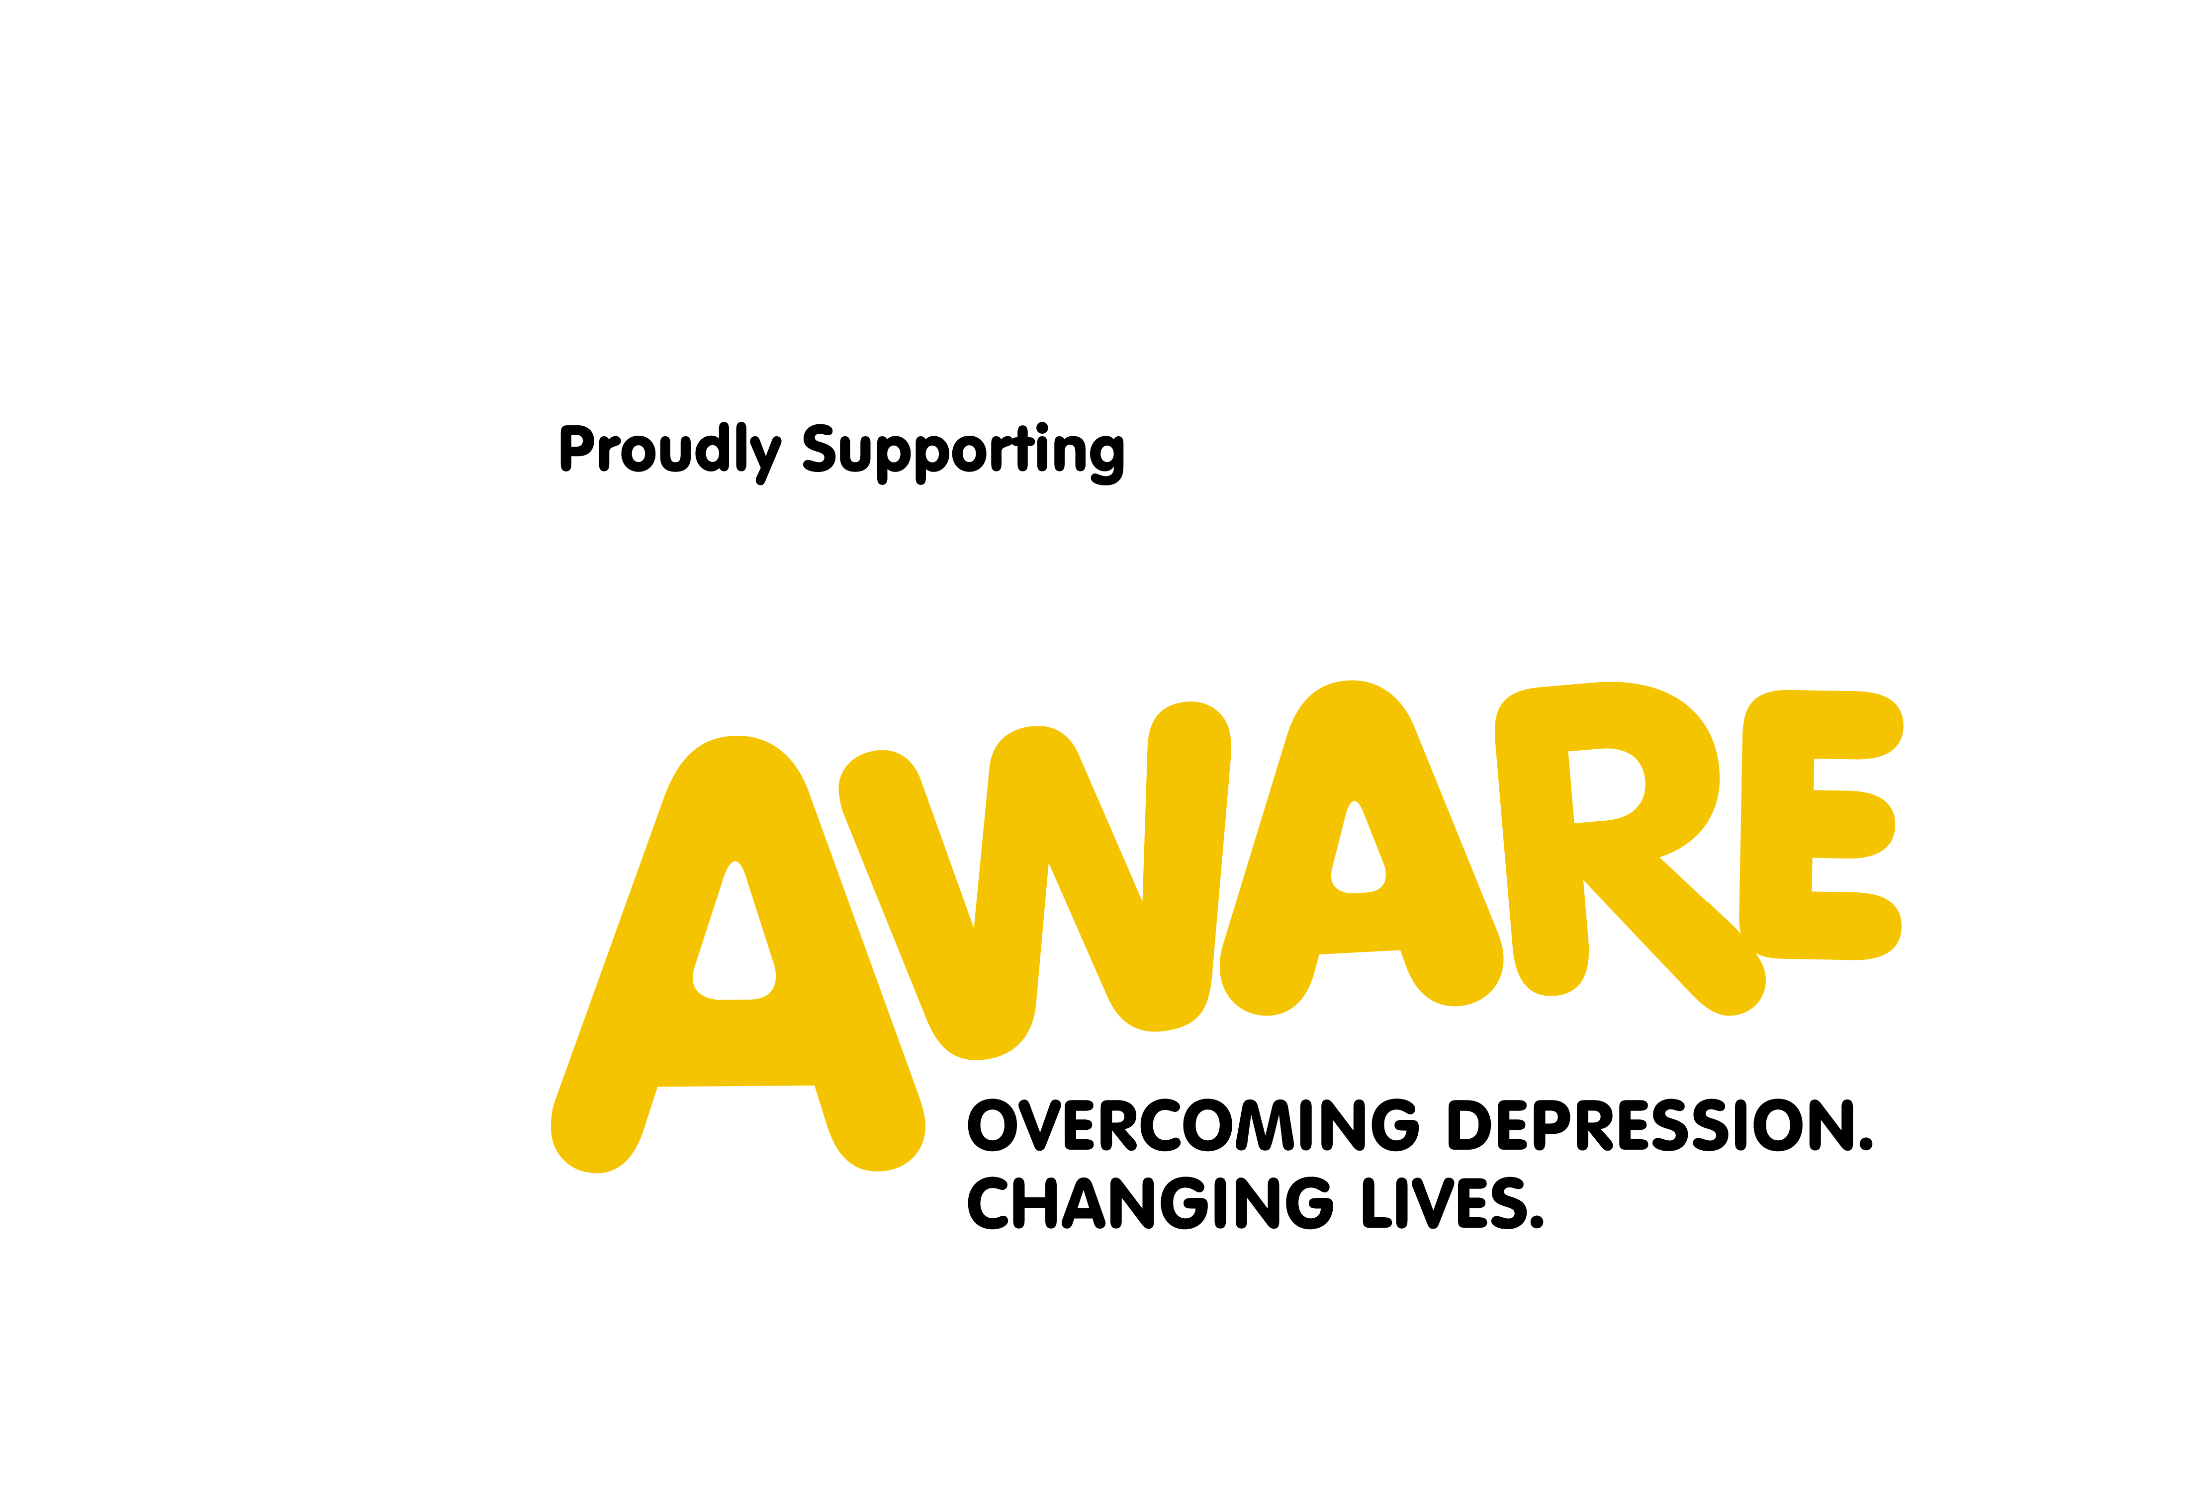

Schedule
Ridden Classes
- Class 1: LV Intro
- Class 2: LV Prelim
- Class 3: LV Novice

Special Edition Classes
- Class 4: On Foot Freestyle - Just record a routine (60 – 90 seconds duration) incorporating at least 4 of the movements demonstrated in our instructional video on our Facebook page, concluding the video with the essential salute and a big cheesy grin to win over the judges!
- Class 5: TikTok Challenge (£5 entry) - Make your own equine inspired TikToks by sending us your videos of you doing one of the TikTok dances incorporating your horse, pony or substitute horse and use #laurelviewxhomeandaware.

Prices
- Minimum £10 per entry & two entries for £15.
- Entry only £5 for our special TikTok class.

Key Dates
Entries open Sunday 24th May & Close 1pm Sunday 7th June.
Results will be announced 9pm Monday 8th June.

Where to find tests
Tests can be located both on our website www.laurelview.co.uk and on the Virtual Charity Dressage Facebook event page: https://bit.ly/2ATtKLb

Payment and entry
- To pay you simply visit our Just Giving page https://bit.ly/3bS6bit A link can also be found on our website and Facebook page.
- Make the appropriate contribution for the number of classes you intend to enter, making sure your full name which you wish to enter with is visible, if not, leave your name in the section where you can leave ‘Aware’ a message.
- You can then send us your recordings via Whatsapp (07923372605) or Laurel View Messenger or to laurelview01@btinternet.com along with the horse and rider name and class or classes you wish to enter.
These processes enable us to check everyone has entered and made at least the minimum appropriate entry contribution. If you have any issues, please do not hesitate to contact us.

How to record tests
- All ridden tests must be recorded landscape (holding your phone sideways). Special edition classes can be recorded in either a landscape or portrait format.
- For ridden tests, the full arena must be in view, allowing the judges to accurately judge your test with a more realistic viewpoint.
- For the ridden tests try to keep the camera in the same position. This can be achieved with a tripod or just propping the camera up with in an appropriate position with any suitable objects. Alternatively, you can ask someone to film the test for your whist remaining as still as possible.

What to wear
- Competitors can wear whatever they prefer, whether that’s full show attire, normal clothes, fancy dress or if you just want to roll out of bed, pyjamas, we don’t mind.
- There will be a prize for the three best fancy dress participants overall!
- Normal dressage rules for horse tack still apply for our ridden classes.
- However! Entries for ridden classes will be rejected if you are not wearing the appropriate safety equipment: riding hat and boots. Furthermore, we would like to remind everyone opting to wear fancy dress to please be mindful of both their and their horse’s safety.

Summary of Aware NI
AWARE has an established network of 23 support groups in rural and urban areas across the country, which are run by trained volunteers. Support groups welcome people with depression and bipolar disorder as well as carers for people with the illness. They also deliver Information Outreach sessions and attend community events to give more information about AWARE and its services. AWARE deliver mental health and well being programmes into communities, schools, colleges, universities and workplaces. These programmes include a suite of Mood Matters programmes, Living Life to the Full, Mental Health First Aid and Mindfulness.
#HomeAndAWARE is about coming together while staying apart at home to improve your mood and feeling of wellbeing whilst also helping to raise awareness about mental health and vital funds that will help AWARE to continue to support the many people in Northern Ireland that are struggling with their mental health.
For more information visit: https://www.aware-ni.org/

On behalf of everyone at Laurel View I would like to sincerely thank everyone for their support of our Virtual Charity Dressage Competition. Your support of this incredible charity means a great deal to us.
xxx

