**Laurel View Junior Pony Club**

**Saturday 3 – 4.30pm**

**September**

27th – Badge presentations and information session

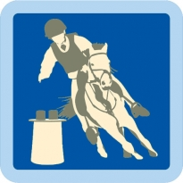**October**

11th/18th/25th – Intro to Mounted Games Badge

**November**

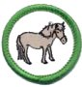8th/15th/22nd – Point of Tack Badge &

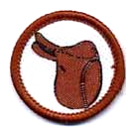Points of Pony Badge

**December**

6th/13th - Efficiency test revisions – E & D Tests

11th – Junior and Senior Pony Club Christmas Party!

30th – Efficiency Tests Day

[](http://www.google.co.uk/url?url=http://www.pcuk.org/index.php/tests_and_achievements/achievement_badges_basic/equine_achievement_badges&rct=j&frm=1&q=&esrc=s&sa=U&ei=2bgWVN_0Lem57Ab9gYGoDQ&ved=0CBYQ9QEwAA&usg=AFQjCNH3TPPHOea00MLHlFZtKfqyjM3xaA)**January**

17th/ 24th – Make your own horse Treats

31st – Rider Nutrition Badge

**February**

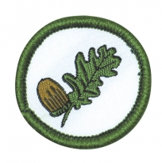14th/21st/28th – Rider Nutrition Badge

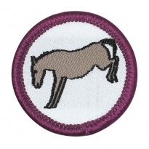**March**

14th/21st/28th – Poisonous Plants Badge

**April**

11th/18th/25th – Pony Behaviour Badge

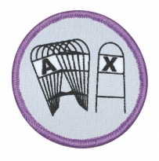**May**

16th/23rd/30th – Fun and Games with ponies!

**June**

13th/20th/27th – Dressage Arena Badge