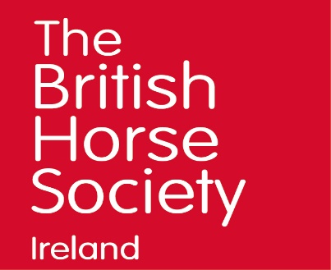
Safeguarding Children & Young People in Sport Course
BHS Northern Ireland & Republic of Ireland
Safeguarding Children and Young People in Sport Course
1 April 2019 – 6.30 to 9.30pm at Laurel View Equestrian Centre, Co Antrim

Child Protection in Northern Ireland is fully devolved to the Northern Ireland Executive and Northern Ireland Government Departments, in particular to the Department of Health, Social Services and Public Safety (DHSSPS). A range of other departments have responsibility for elements of safeguarding. The primary piece of legislation is the Children (Northern Ireland) Order 1995.

We have a legal and moral duty of care to protect all children and young adults involved in horse activities.
The Safeguarding Children and Young People in Sport course outlines the roles and the responsibilities that we and other British Equestrian Federation (BEF) member organisations have in our duty of care towards young people, and includes guidelines on protecting young people and promoting good practice within the Equine Industry.

This course needs to be updated every three years. It is suitable for those wishing to join the British Horse Society Accredited Professional Coach Register and take BHS Assessments.

Delegates need to be 18 years or over or 17 years and accompanied by another paying adult to attend.

Cost:
BHS Accredited Professional Coach –normally included as part of registration
All Others: £35

Date:

Monday, 1 April , 6.30 to 9.30pm
at Laurel View Equestrian Centre, Templepatrick, Co Antrim BT39 0BX

Please ensure the appropriate registration fee is enclosed with this form.

Payment can be made by Paypal to s.irwin@bhs.org.uk, cheque or cash.

Please return to:
Susan Spratt (Mrs)
British Horse Society Manager for Northern Ireland & Republic of Ireland
Hawks Hill Cottage, 26 Portaferry Road, Greyabbey, Newtownards, Co Down, BT22 2RU
{+00447808141079, susan.spratt@bhs.org.uk}

For more information on anything contained above contact:
Susan Spratt, BHS Manager for Northern Ireland & Republic of Ireland
e: susan.spratt@bhs.org.uk t: 0044(0)07808141079 w: www.bhs.org.uk

