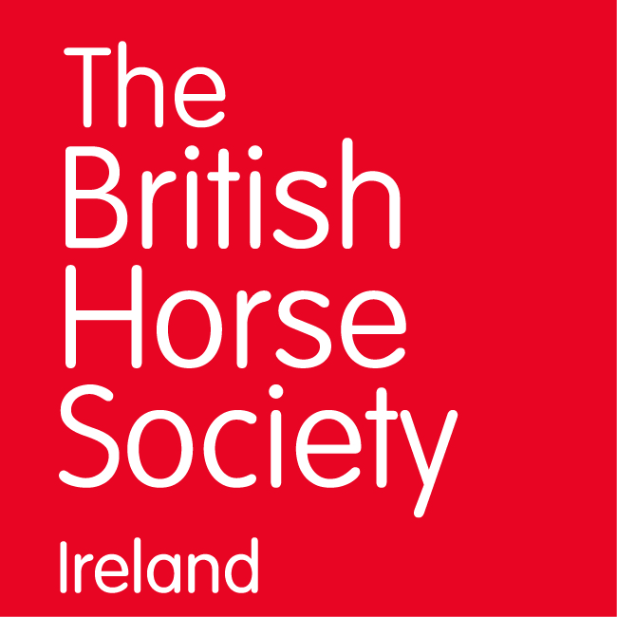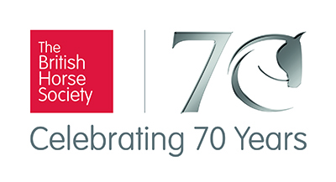
“Equine Excellence Standard Setting and Revision Days”
with Patrick Print OBE FBHS and Chief Assessor
Monday 5 February 2018 - Stages 2 and 3 Teach - 1.30pm to 5.30pm
Tuesday 6 February 2018 - Stages, 1, 2, & 3 - 9.30am to 4pm
Venue: Laurel View Equestrian Centre, 18 Knowhead Road, Templepatrick, Co Antrim BT39 0BX
The cost is £30/ 30 euro per person.
Spaces are Limited so book quickly.

These days provide a fantastic opportunity to learn more about the launch of the new British Horse Society’s Equine Excellence Pathway. These days will cover a range of demonstrations and presentations which will give you an insight into the new developments in the Stages 1, 2 & 3.
These sessions are open to all to attend and will be of particular benefit to:
Accredited Professional Coaches
Proprietors of BHS Approved Centres
Those in training or considering taking training for the new qualifications.
Stages 2 and 3 Teach:
Monday, 5 February 2018
Patrick Print OBE, FBHS and Chief Assessor will be explaining the new BHS Equine Excellence Pathway and demonstrating the requirements for BHS Stages 2 and 3 in teaching.
Programme for the day
1.30pm Arrival
2pm Discussion on new coaching assessment at level 3
2.30pm Coach a private Dressage session to novice level
3.30pm Coach a simulated cross-country session to 2 riders at novice level
4.30pm Discussion to include Ride Safe Assessment
5.30pm Finish
This course counts as four hours of Continual Professional Development (CPD) for the BHS Accredited Professional Coach Register. (A total of six hours of CPD is required every two years)

Stages, 1, 2, & 3
Tuesday, 6 February 2018
Patrick Print OBE, FBHS and Chief Assessor will be explaining the new BHS Equine Excellence Pathway and showing the requirements for BHS Stage 1, 2 and 3 in riding, horse care, lungeing and teaching.

Programme for the Day
9.30am Arrival
10am Discussion of the new BHS Equine Excellence Pathway
11am Stage 1 flat and pole work demonstration
11.30am Stage 2 & 3 flat work and jumping demonstration
1pm Lunch (working discussion) (Lunch is provided)
1.45pm Stage 2 & 3 lungeing demonstration
2.30pm Stables – Stage 1, 2 and 3 Care
3.30pm Finish and discussion

This course counts as six hours of Continual Professional Development (CPD) for the BHS Accredited Professional Coach Register. (A total of six hours of CPD is required every two years)

Book these courses with Susan Spratt – details below.

Information required:-
Name:-
Mobile Number:-
Email address:-
BHS Gold Membership Number:-
Dietary Requirements:-
Any further information we should know:-

Pre-booking is essential - You may pay by Paypal to s.irwin@bhs.org.uk

For more information on anything contained above contact:
Susan Spratt (Irwin) BHS Manager for Northern Ireland & Republic of Ireland
e: susan.spratt@bhs.org.uk t: 0044(0)07808141079 w: www.bhs.org.uk

