**Laurel View Senior Pony Club**

**Thursday 7 - 8.30pm**

**September**

25th – Badge presentations and information evening

for young people and parents

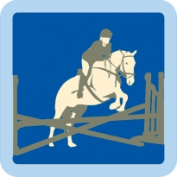**October**

9th/16th/23rd – Introduction to Show Jumping Badge

**November**

6th/13th/20th – Efficiency test revisions – D, D+ & C Tests

**December**

4th- Efficiency test revisions – D, D+ & C Tests

****11th – Junior and Senior Pony Club Christmas Party!

30th – Efficiency Tests Day

**January**

15th/22nd/29th – Public Speaking Badge

**February**

12th/19th/26th – Equipment Safety Badge

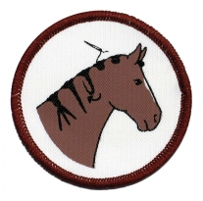**March**

12th/19th/26th – Plaiting Badge

**April**

16th – Plaiting review and Test

23rd/30th – Mounted Games

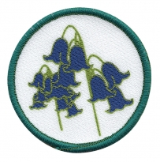**May**

21st/28th – Fun and Games with ponies!

**June**

11th/18th/25th – Wild Flowers Badge