**Laurel View Pony Club**

**Thursday 6.30-8.30pm**

**September**

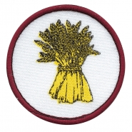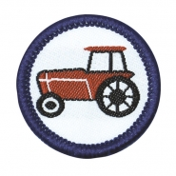24th – Badge presentations and information session

**October**

1st/8th/15th – Farming Badge

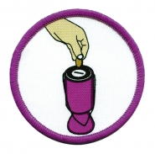**November**

5th/12th/19th – Fundraising Badge

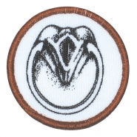**December**

3rd - Trotathon!!

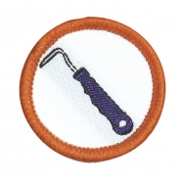10th –Pony Club Christmas Party!

30th – Efficiency Tests Day

**January**

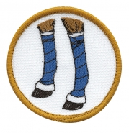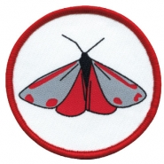7th/14th/21st – Area Quiz Practice &

Equestrian fun and games

**February**

4th/11th/18th – Care of the foot Badge

**March**

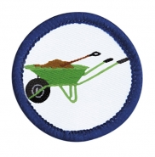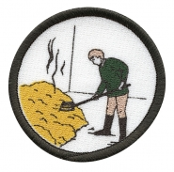3rd /10th/17th – Horse Clothing/Bandaging and Rugs

24th – Road Rider Test Day

**April**

7th/14th/21st – Butterflies and Moths

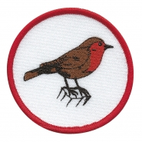 **May**

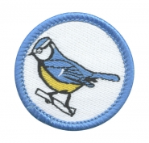5th/19th/26th – Mucking Out Badge

**June**

2nd/9th/16th – Birds and Birdwatching Badge